‘Lifeline’ - Blood and Plasma Donation Website - Design Documentation

### PREPARED FOR

CSE300 - Software Engineering

School of Engineering and Applied Science, Ahmedabad University

### PREPARED BY

Group 5:

|  |  |
| --- | --- |
| **Group Members:** | |
| Shivani Kadam (AU1841133) | Dishita Madani (AU1841112) |
| Aisha Nagrecha (AU1841137) | Yesha Ajudia (AU1841078) |
| Manasvi Dobariya (AU1841053) | Kartavi Baxi (AU1841079) |
| Darshak Chavda (AU1841063) | Nisarg Thoriya (AU1841142) |

### 1. Product Specification

‘Lifeline’ is a free blood and plasma donation website made as a part of a project in Ahmedabad University. It mainly aims to bridge the gap between the donors and the receivers making the entire donation process an easier one. Hospitals would act as that bridge which would verify whether the donor is eligible for the donation and thus the receiver gets the help whenever needed.

**2. Designs:**

**Design Considerations**

**Goals and Guidelines**

* Design as simple as possible

**Development Methods & Contingencies**

**Security -**

* Our solution should expose only the minimal amount of code possible.
* Ssl certificate , which provides authentication for a website and enables an encrypted connection.

**Architectural strategies**

**Scalability-**

* We have deployed our website using firebase and it will scale linearly as our database increases

**Platform -**

* Firebase: app-development platform on Google Cloud Platform.It provides services like firestore,cloud storage, analytics,and many more .Firebase frees developers to focus crafting fantastic user experiences.

**UI 1 - Login screen**

The user must login to get directed to the dashboard and see the updates regarding his/her donations or any donation requests

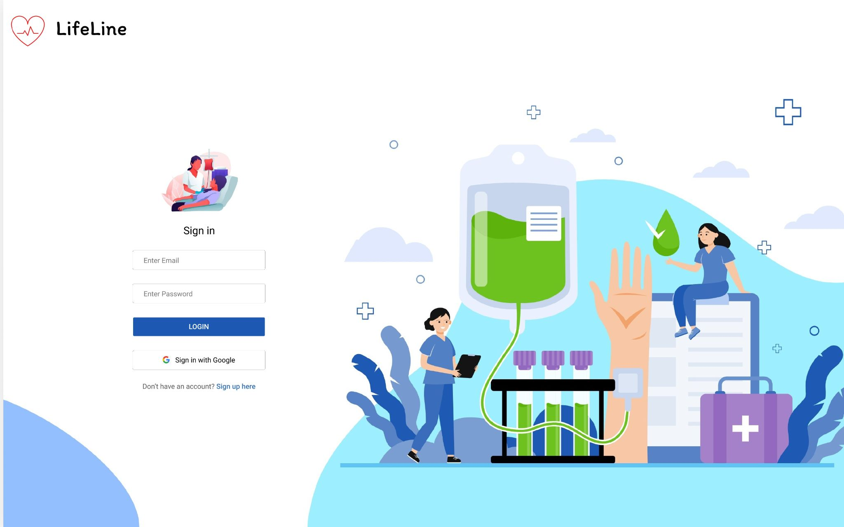

**UI 2 - Signup screen**

If the user is not having an account, he/she could create one either by his/her mail id or even connecting with google

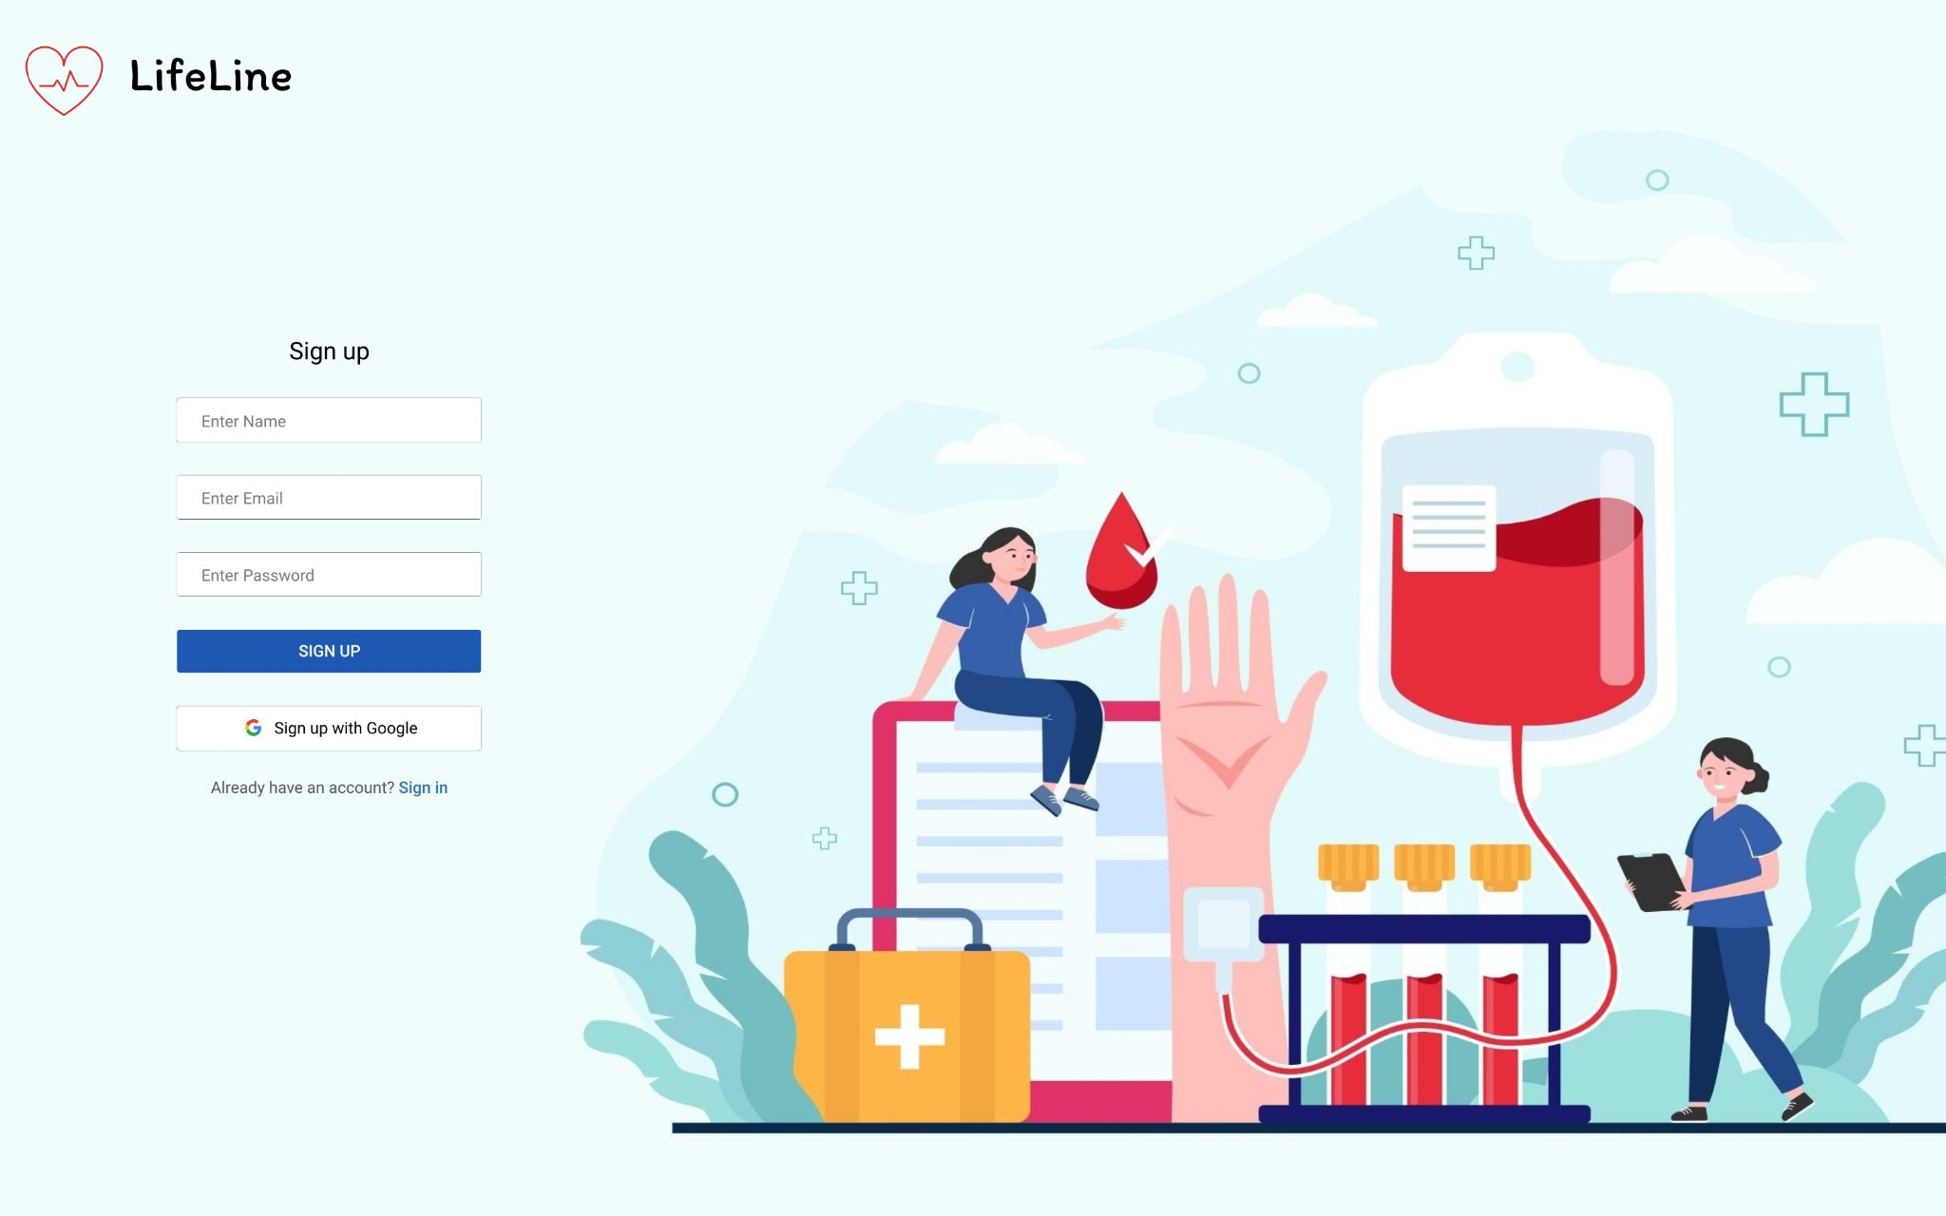

**UI 3 - Dashboard user screen**

The user after successful login will be redirected here and the user can explore other options

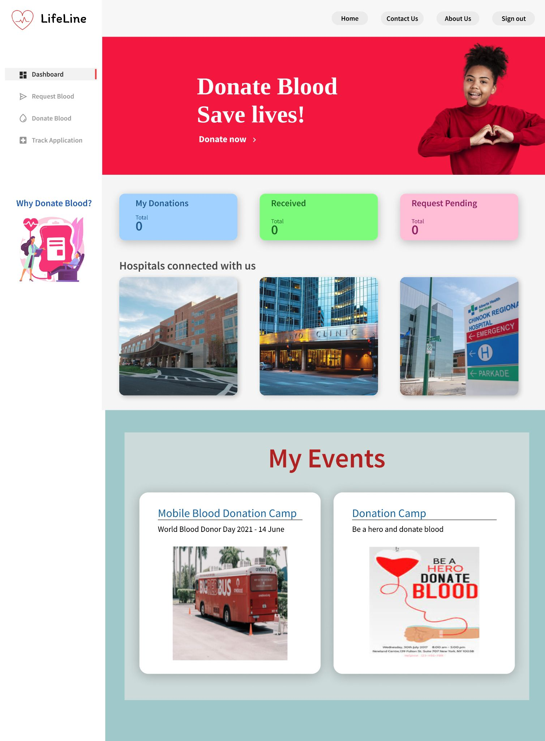

**UI 4 - Homepage screen**

While the user has not logged in, he/she will be on the homepage where they can see the latest news and information and also events that various hospitals are conducting

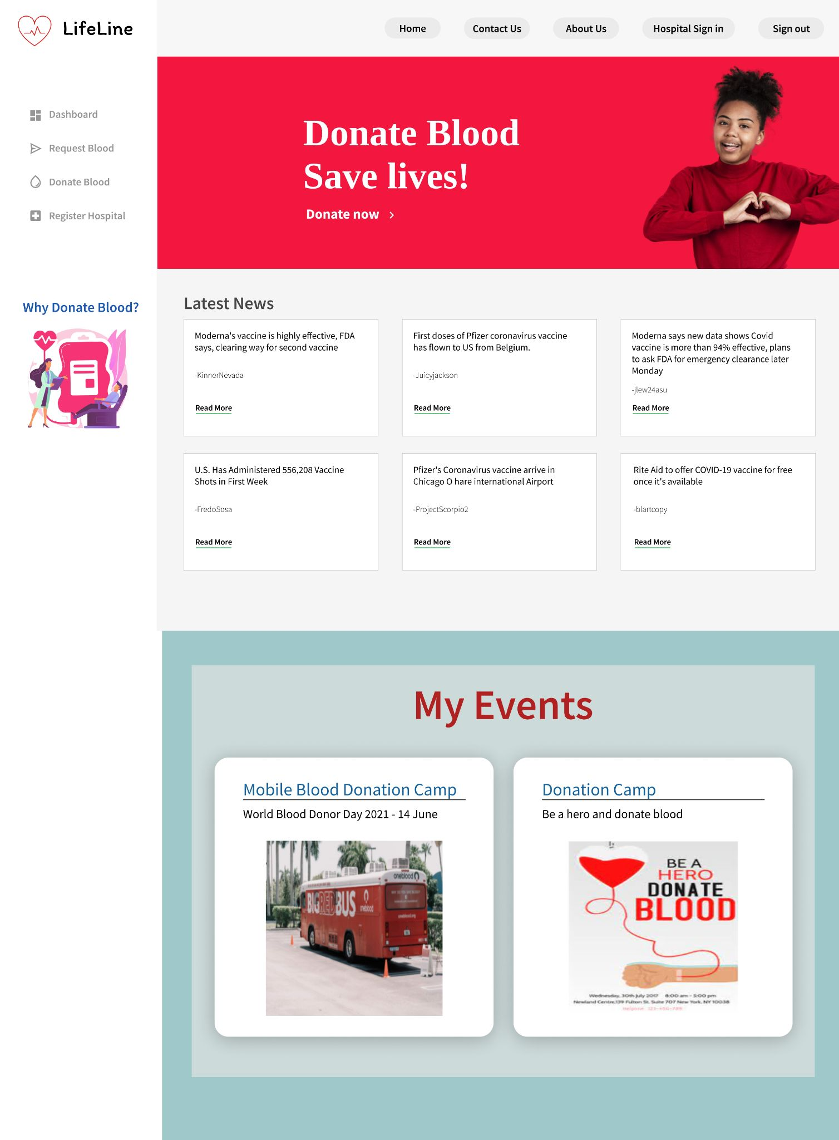

**UI 5 - About us user screen**

Gives the description of the developers of the website

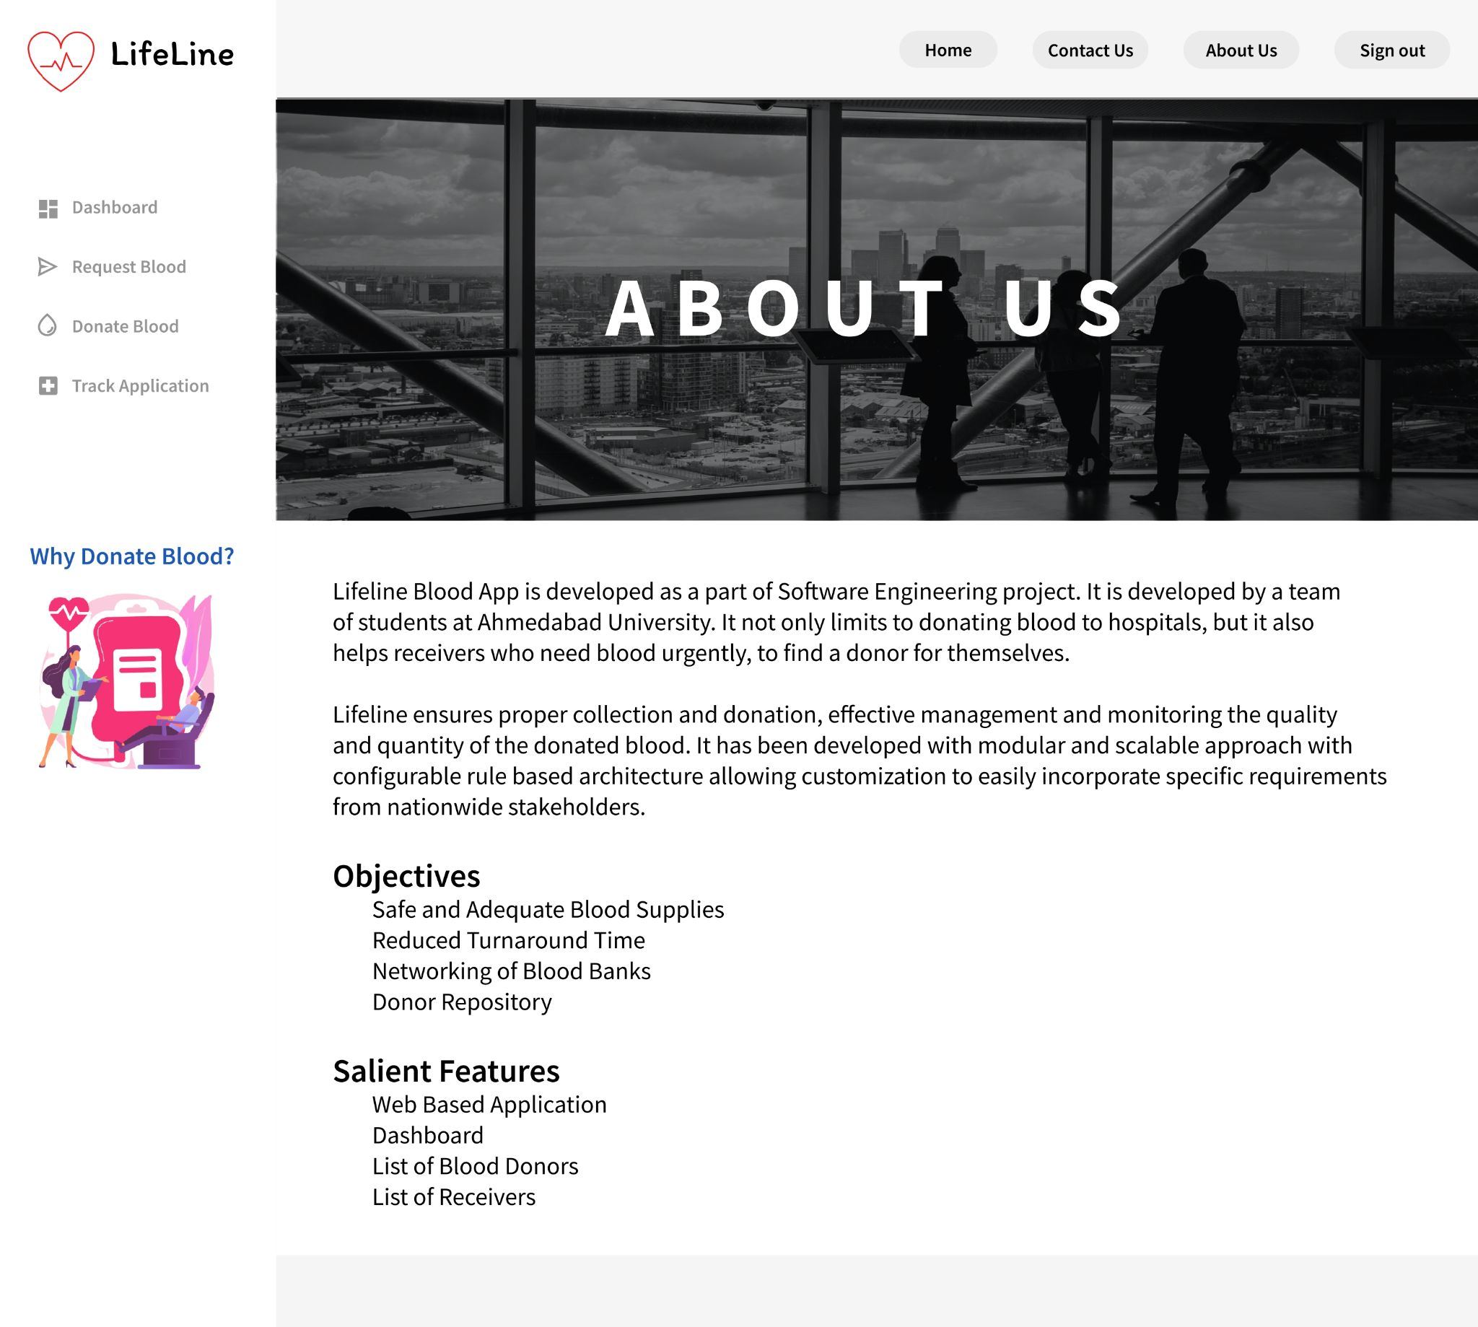

**UI 6 - Request blood screen**

The user through dashboard can navigate here where for making a request to receive blood, he/she needs to fill the form displayed on the screen

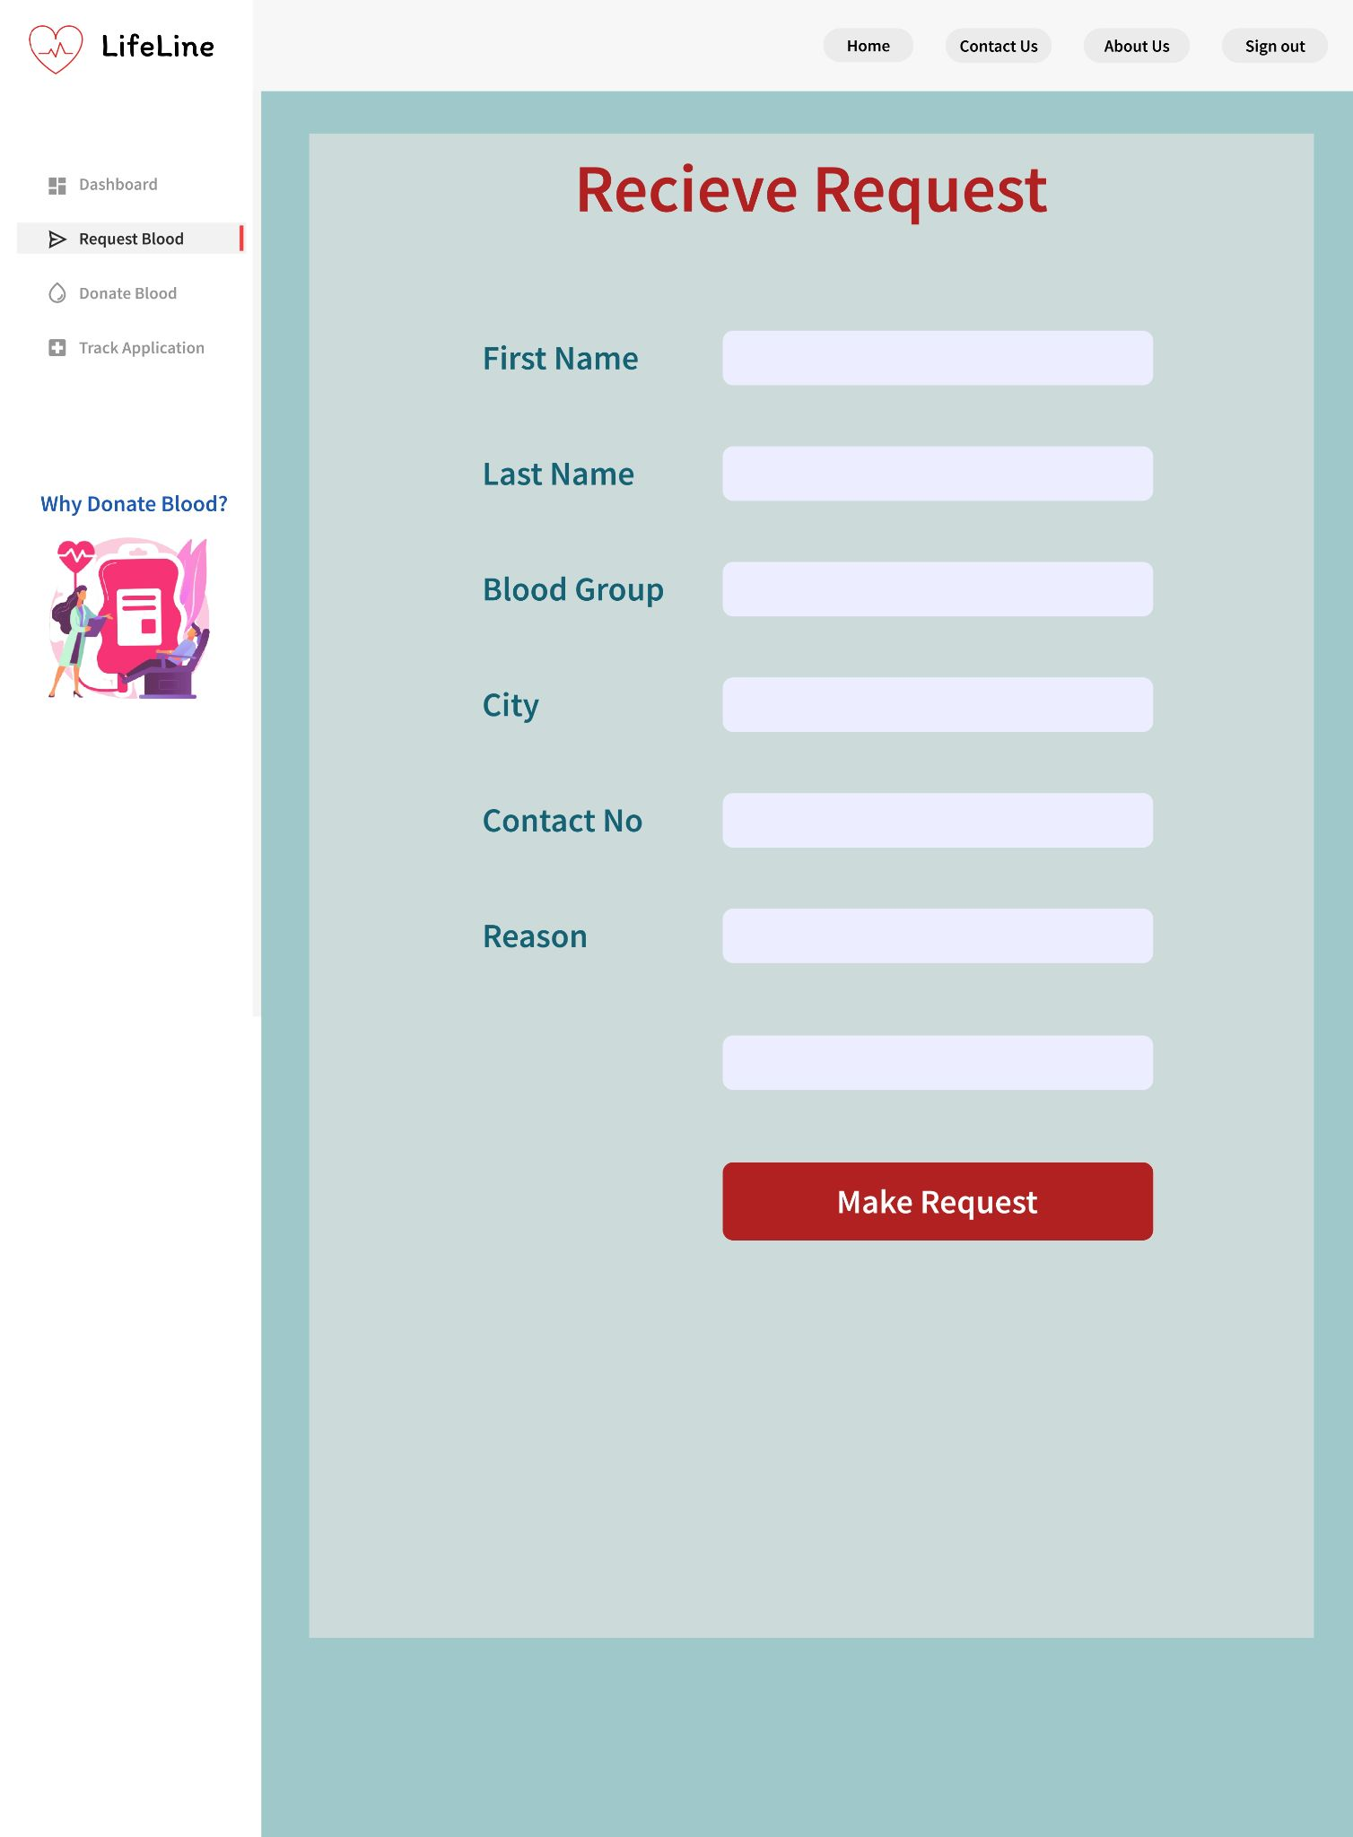

**UI 7 - Medical profile screen**

The user to donate blood must complete the medical profile first

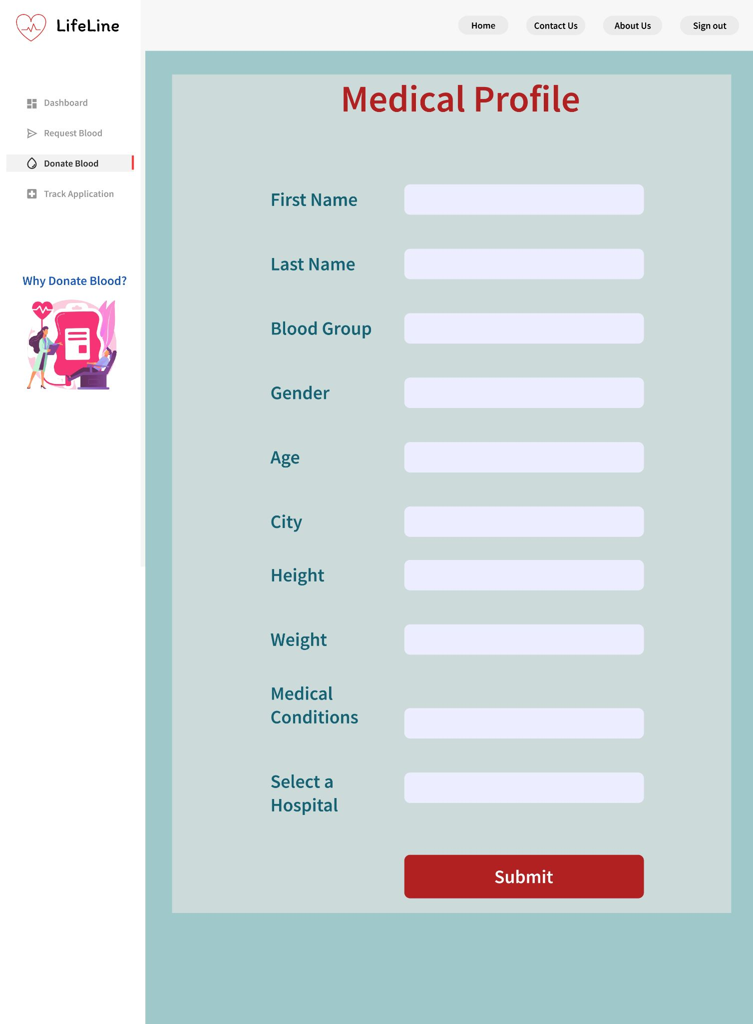

**UI 8 - Why donate blood screen**

The basic purpose of this screen is to motivate its target users to donate blood

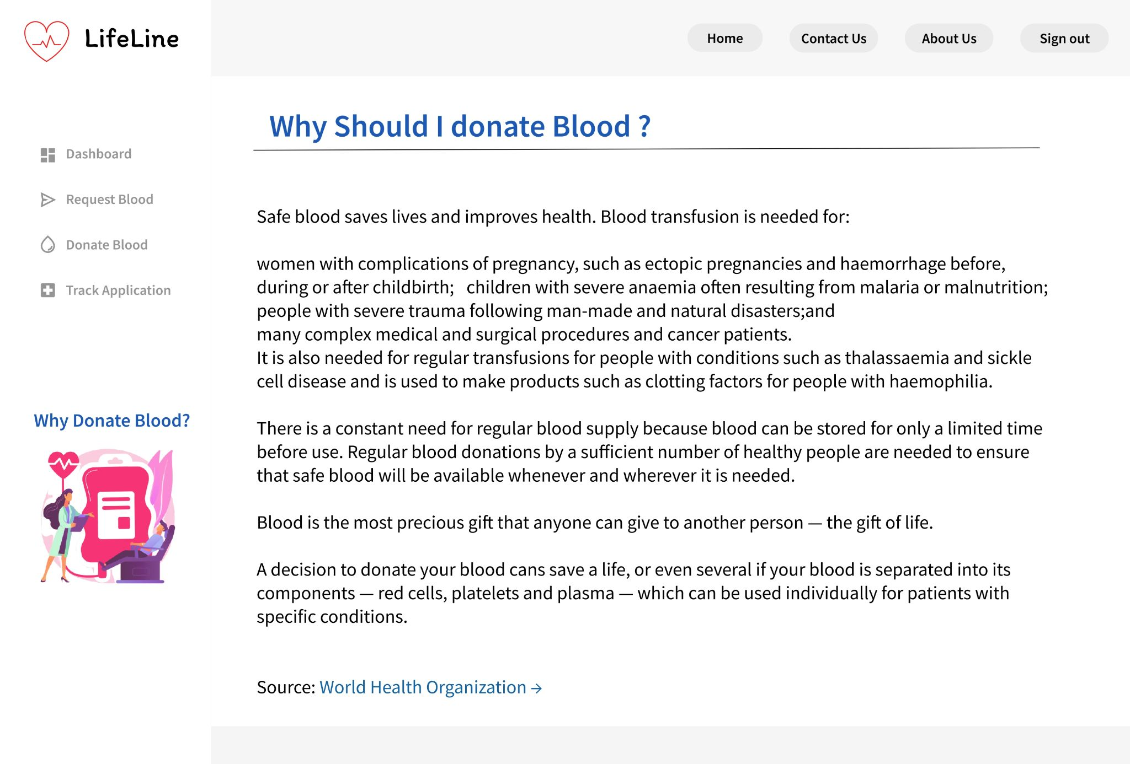

**UI 9 - Contact us screen**

This screen shows the contact details of the website developers when users are having an technical errors

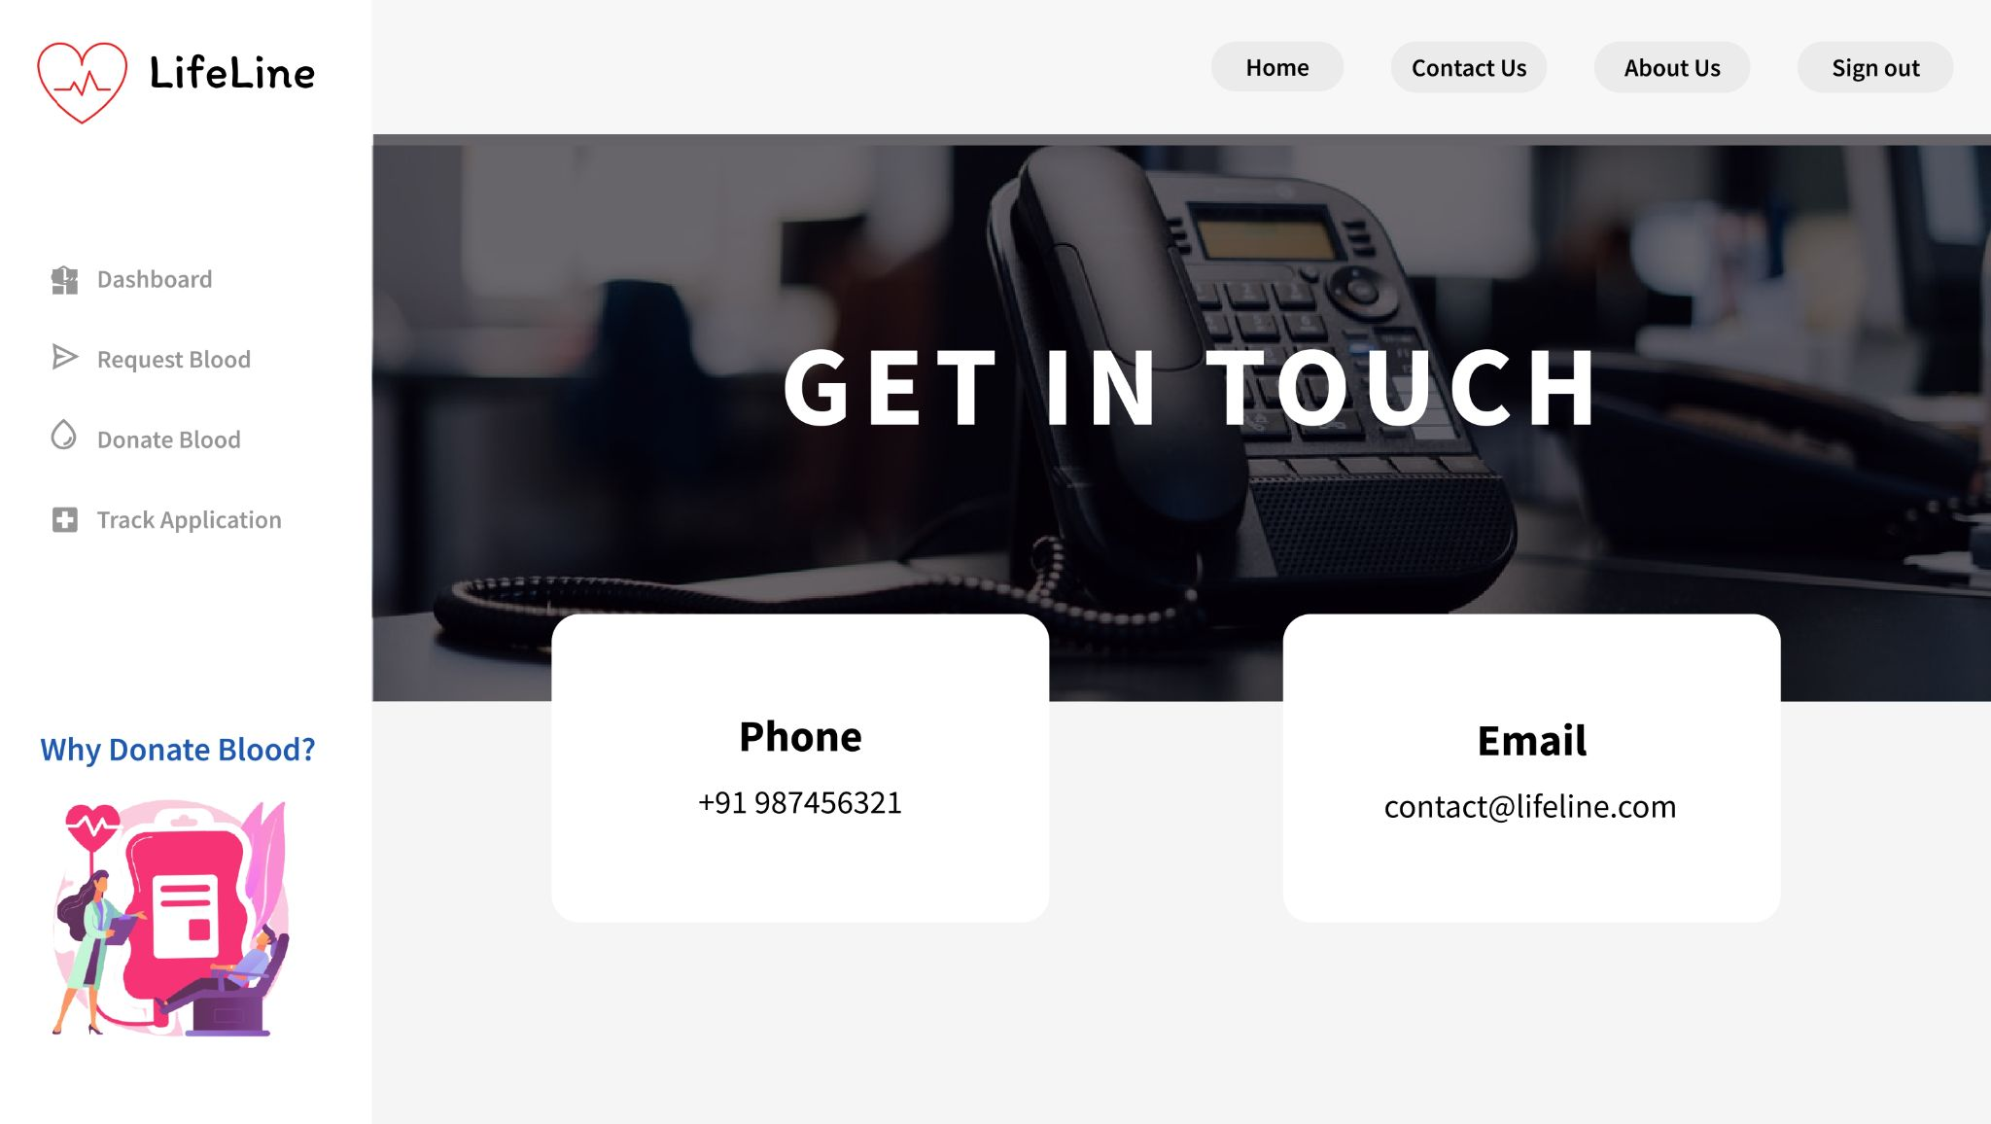

**UI 10 - Hospital login screen**

The hospital must login to get directed to the dashboard and see the updates regarding his/her donations or any donation requests

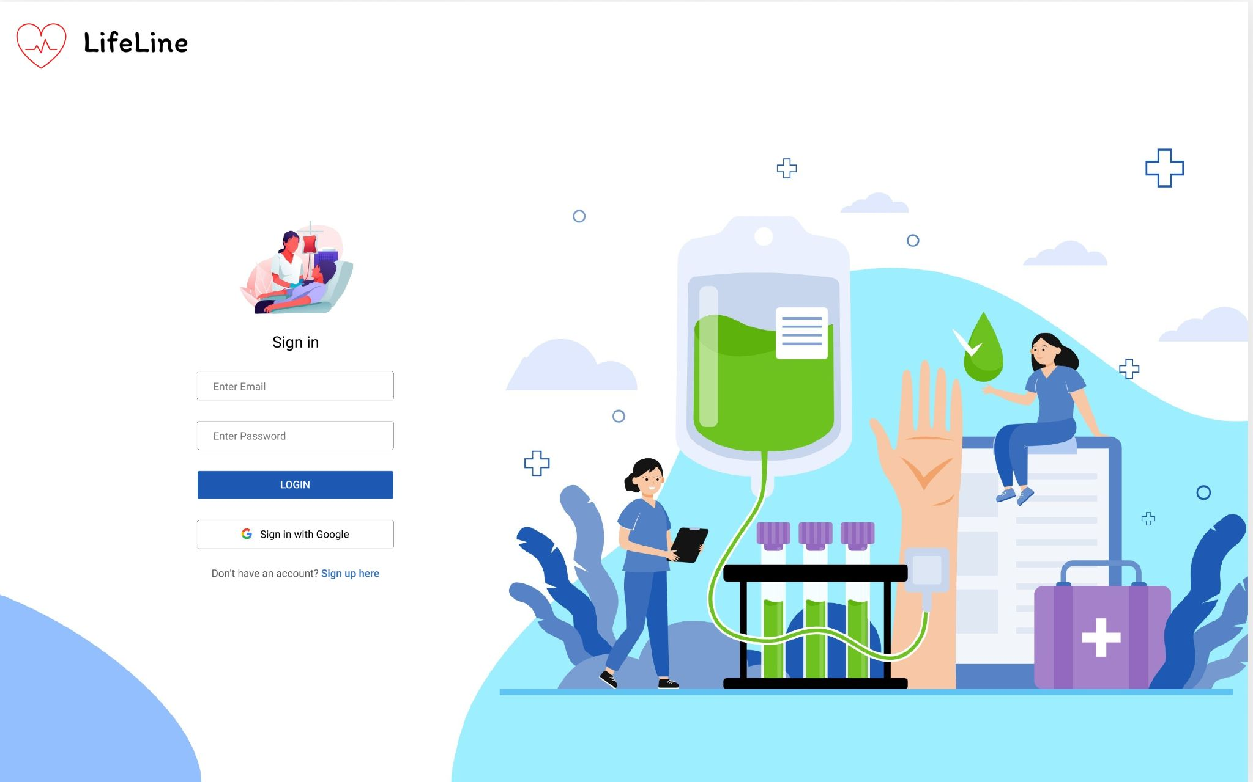

**UI 11 - Hospital sign up screen**

If the hospital is not registered already, they can Register to the website using the License number.

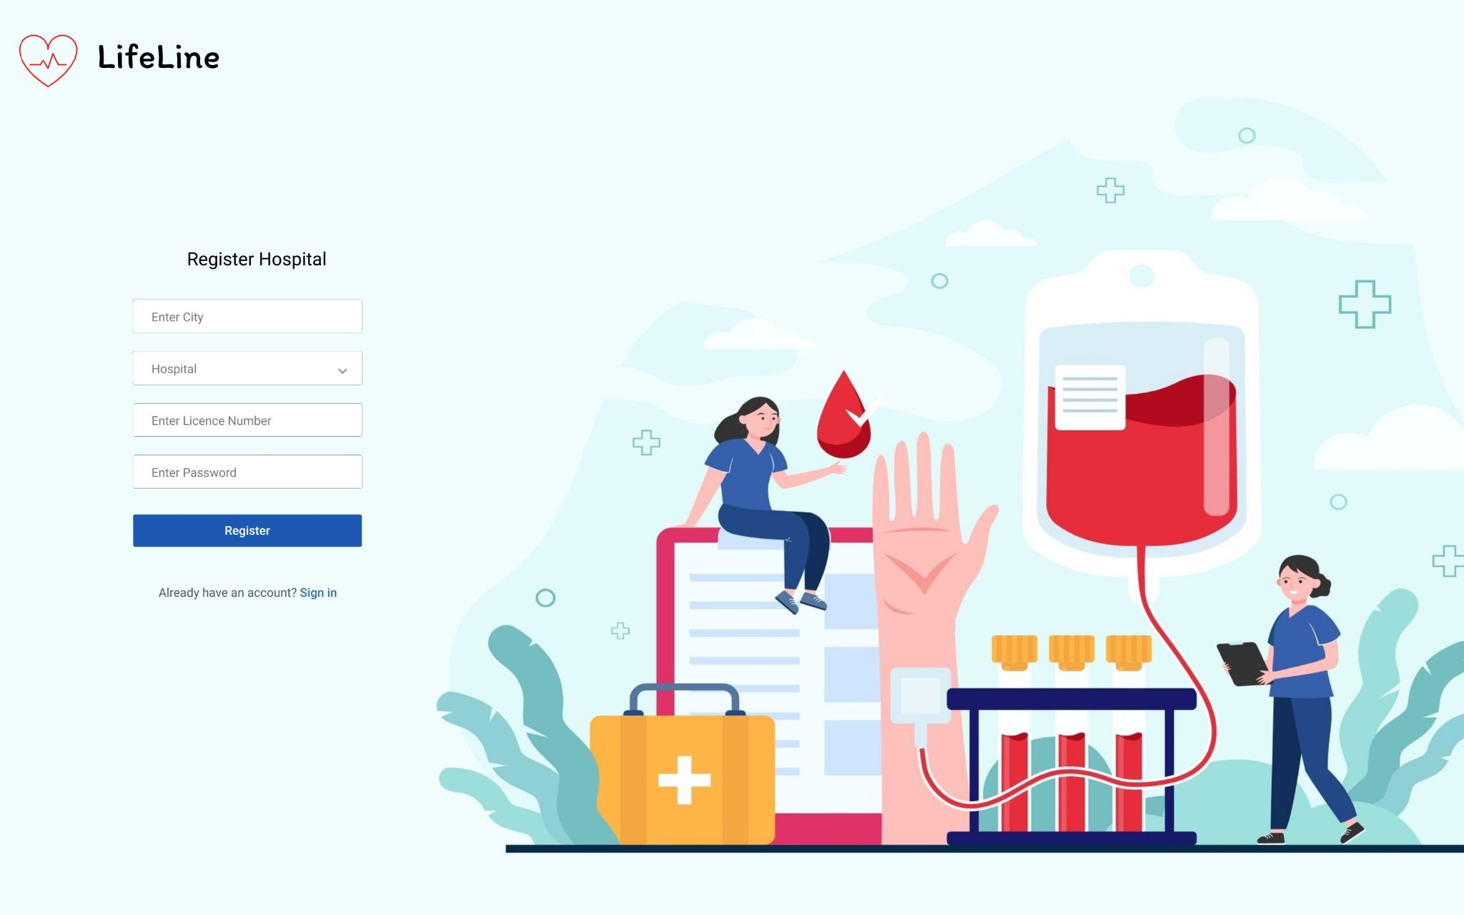

**UI 12 - Dashboard hospital screen**

The hospital after getting registered is redirected to this screen and then they can carry on with the other options

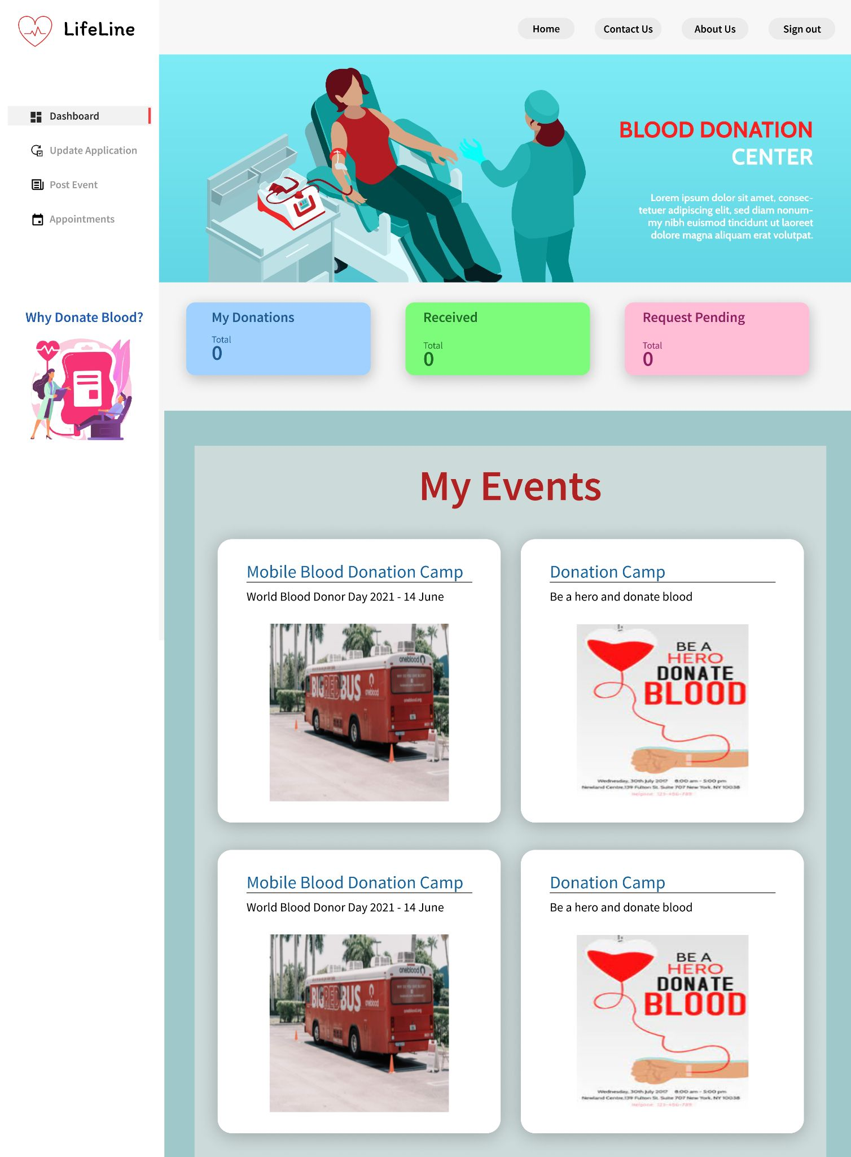

**UI 13 - Update application hospital screen**

Any donor who has made a request to donate blood, his/her profile will first be verified by the hospital and then the status of that application will be updated

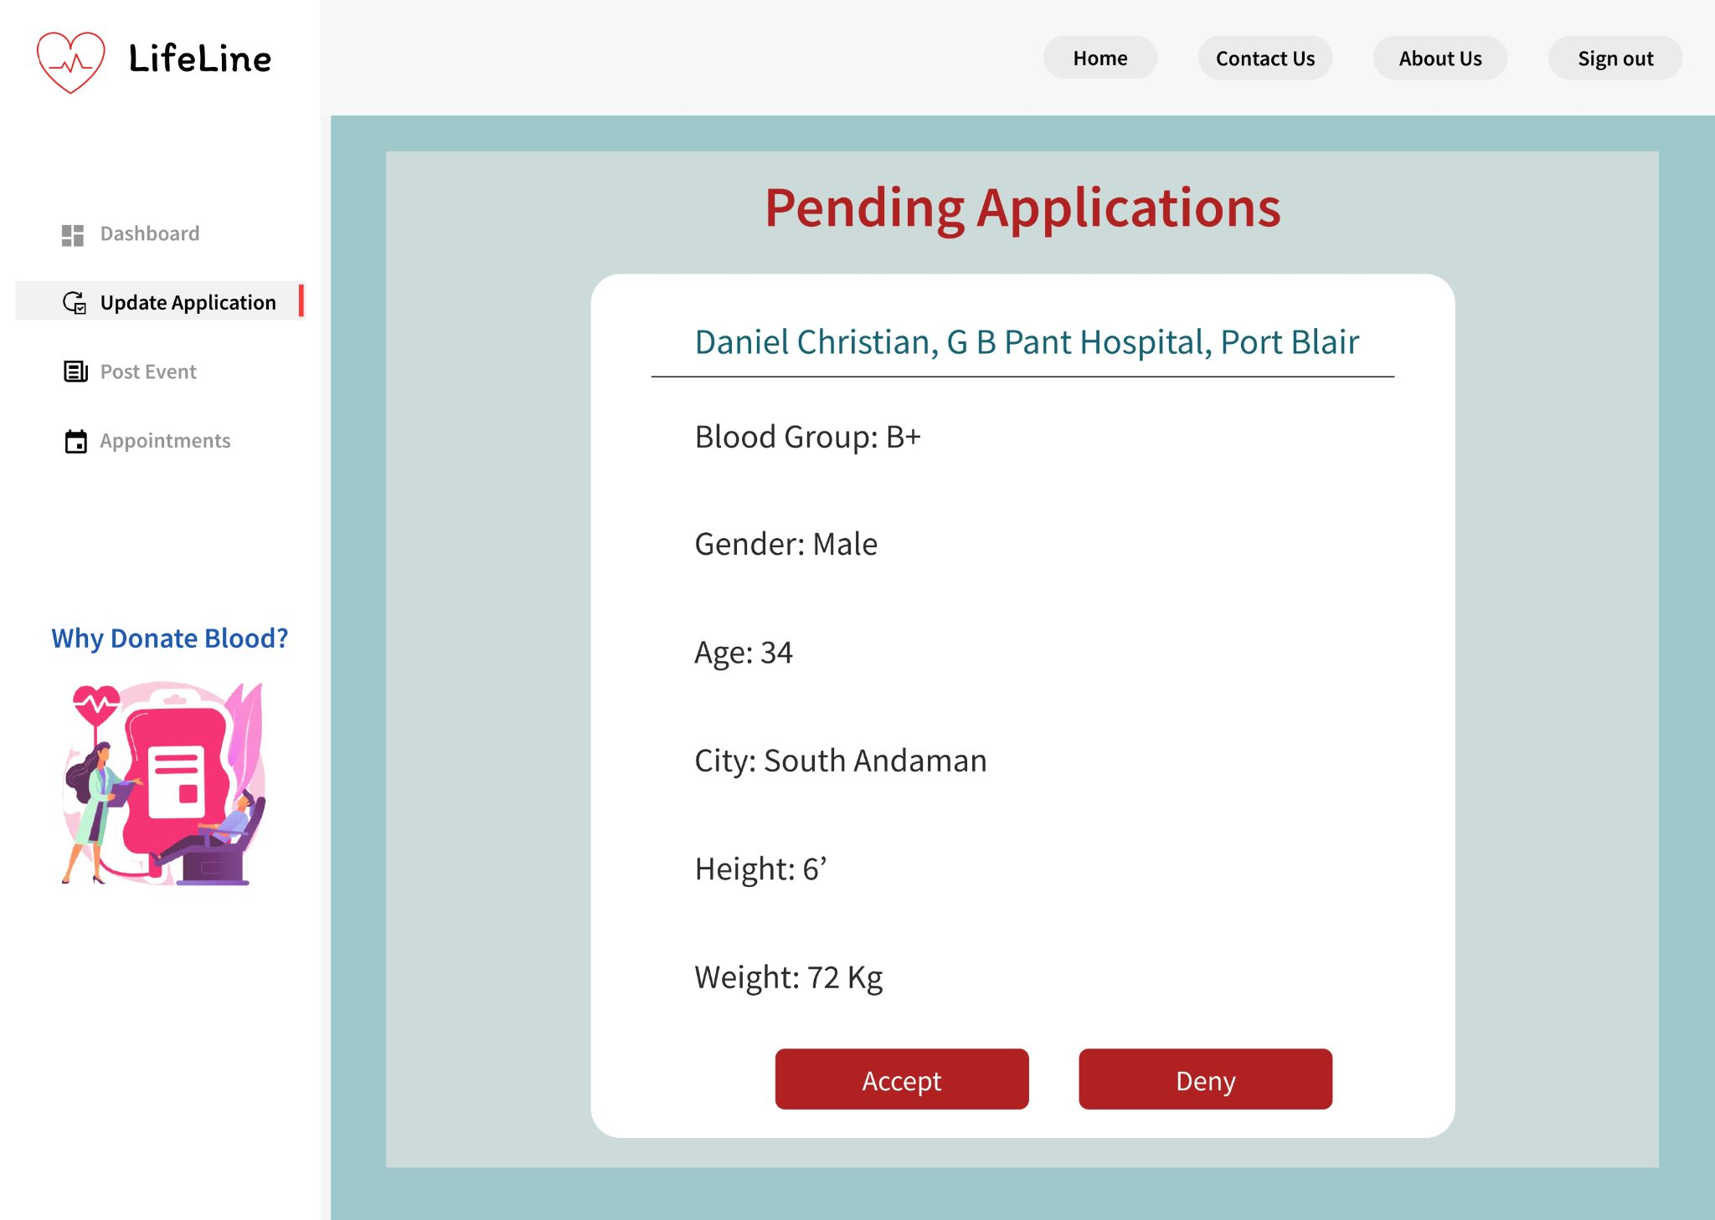

**UI 14 - Add event hospital screen**

Any hospital can add an event regarding any upcoming camps that are going to take place in their premises

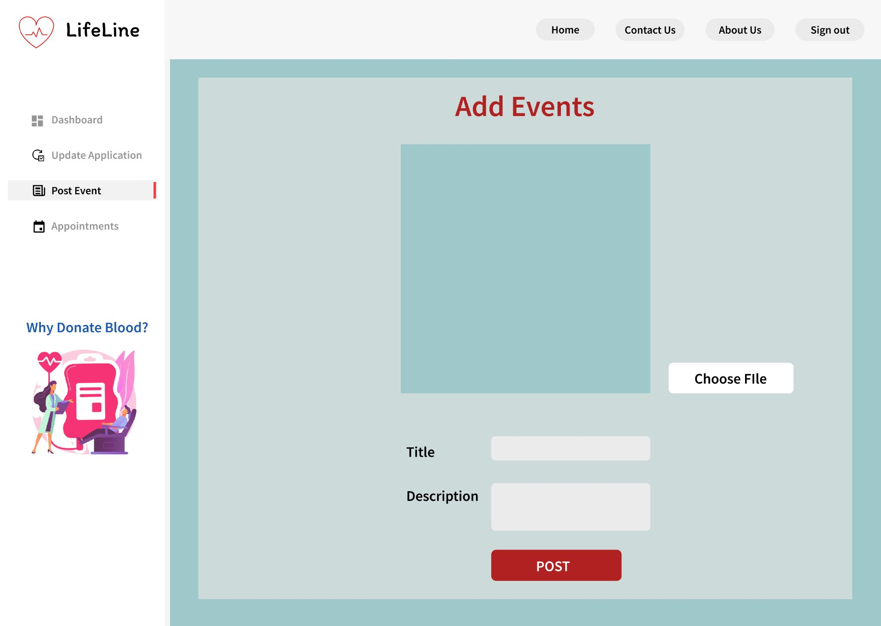

**UI 15 - Appointments hospital screen**

This screen will show the appointments that the hospital is having where a donor is going to make his/her donation

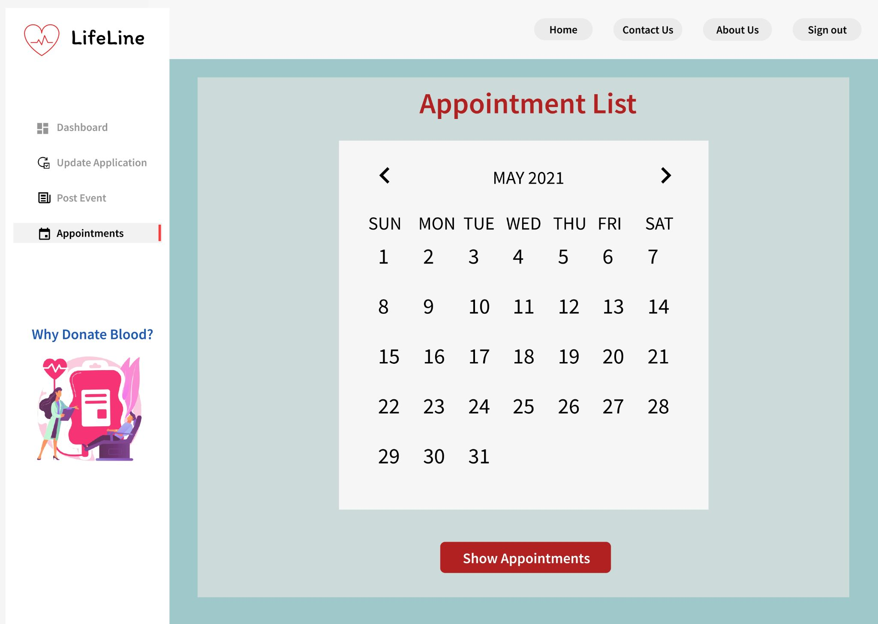

**UI 16 - My events hospital screen**

This screen will show the events that the hospital is having where a donor is going to make his/her donation

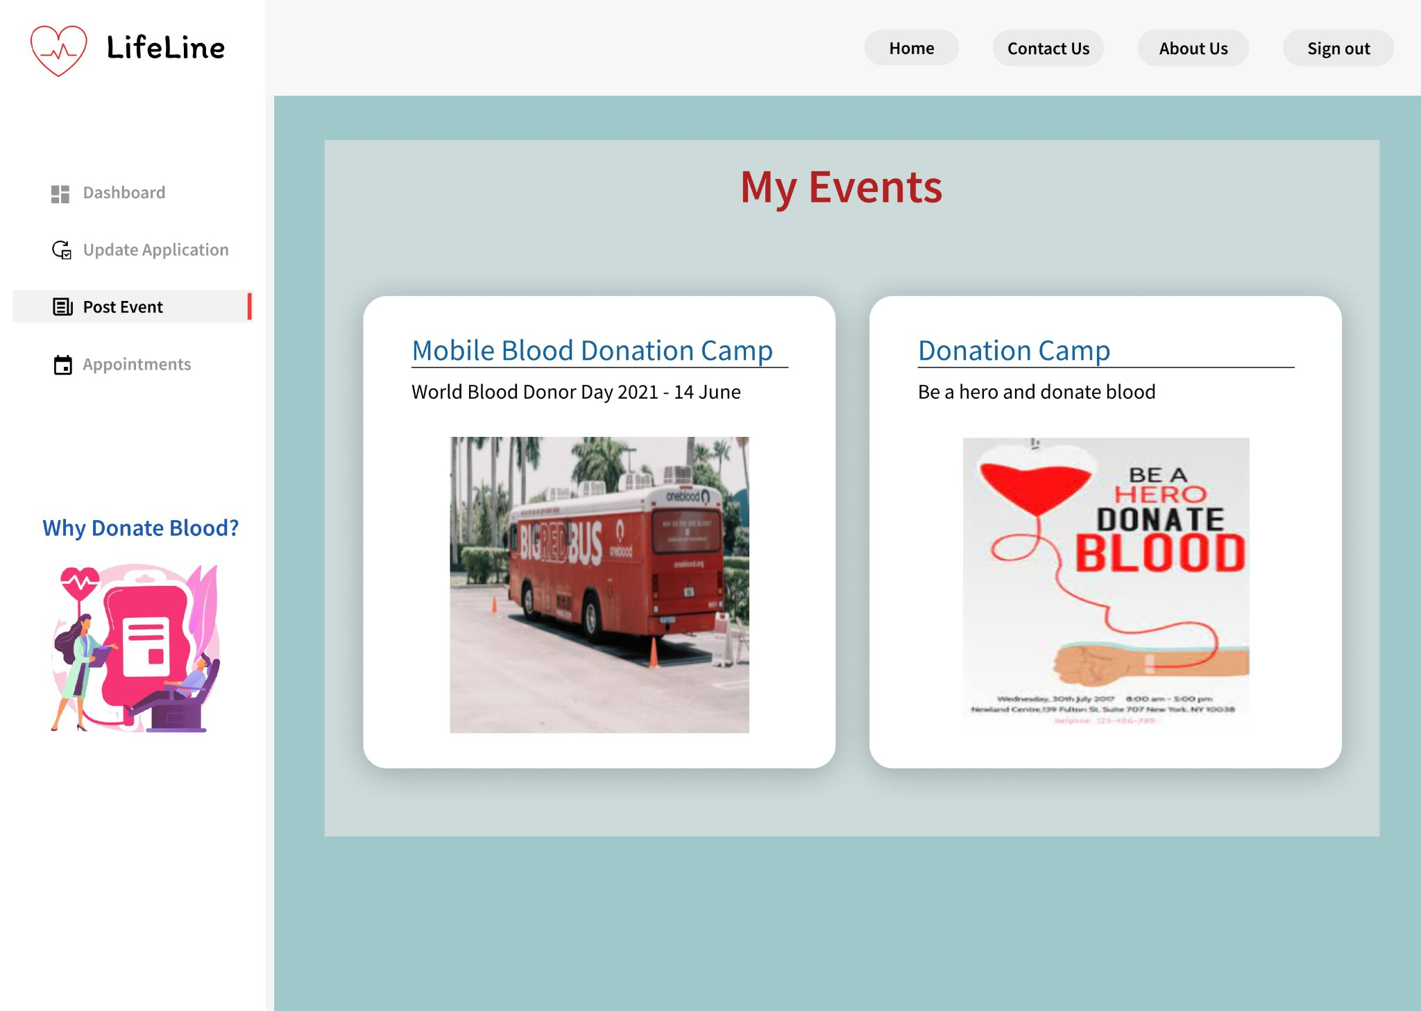

**2.Physical ER:**

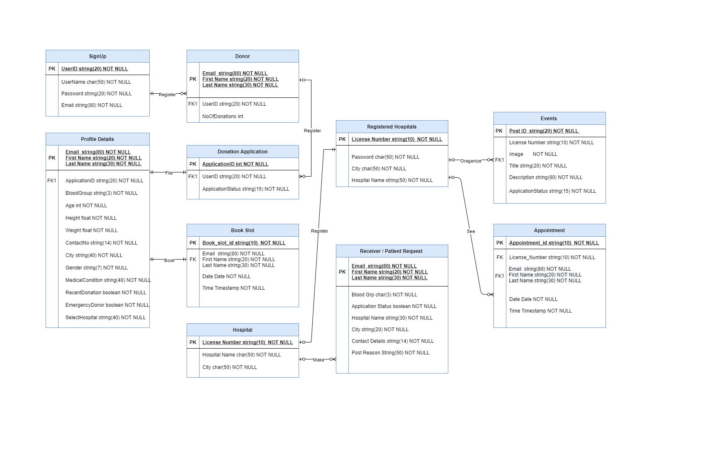

**3. Technical Architecture**

**3.1 Topology Diagram :**

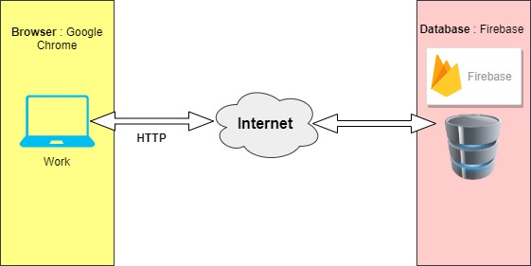

**3.2 Website Architecture Diagram :**

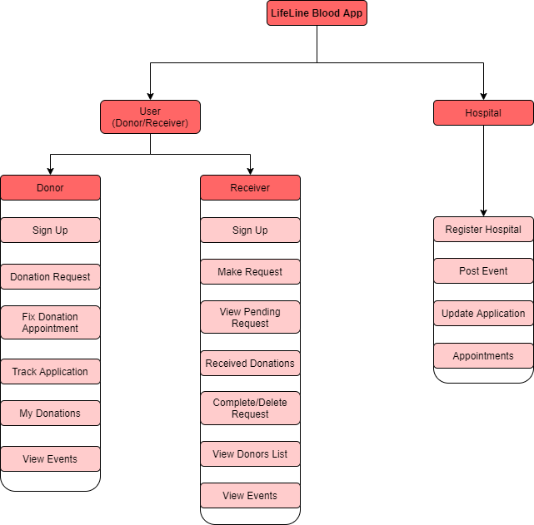

**3.3 Software Architecture :**

**2.3.1 Software Architecture Diagram :**

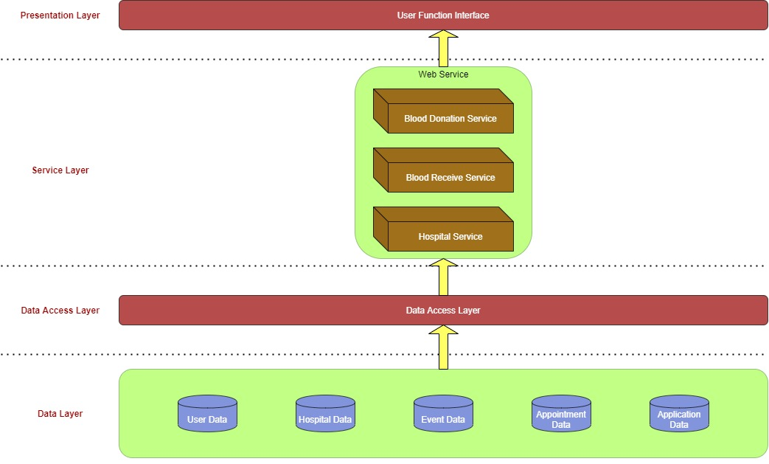

**3.3.2 Software Element :**

|  |  |  |
| --- | --- | --- |
|  | **SYSTEM** | **NOTE** |
| **Frontend Framework** | **React JS** | ReactJS is a JavaScript library used for building reusable UI components. |
| **Backend** | **Firebase** | Firebase is a Backend-as-a-Service (Baas). It provides developers with a variety of tools and services to help them develop quality apps, grow their user base. |
| **Database** | **NoSQL Firestore** | Firestore is a NoSQL document database that lets you easily store, sync, and query data for mobile and web apps - at global scale.We can structure data easily with collections and documents. We can also build hierarchies to store related data and easily retrieve the data that we need using expressive queries. |